
CENTRAL WEST EDUCATION DIVISION
2026 MALAWI SCHOOL CERTIFICATE OF EDUCATION
GEOGRAPHY PAPER I
(100 Marks)
MAP READING AND PHYSICAL GEOGRAPHY
MARKING KEY
SECTION A (75 marks)
Answer all three questions in this section in the space provided.
 |  |  | Bridge | (1 marks)
 |  |  | 711892 | (2 marks
 |  |  | Area: (full squares + half squares / 2)  - Full squares = 6 (1 mark)  - Half squares 12/2 = 6 (1 mark)  - Total squares 6 + 6 = 12 (1 mark)  - Area of 1 square 1km x 1km = 1km² (1 mark)  - Area of 12 x 1km² (1 mark)  - Bangwe = 12km² (1 mark) | (2 marks)
 |  |  | North west | (2 marks)
 |  |  | Farming/settlement/forestry/transportation (any two for 1 mark each) | (2 marks)
 |  |  | Nucleated/compact/clustered | (3 marks)
 |  |  | Not intervisible | (1 marks)
 |  |  | There is a mountain/highland between them
 |  |  | 79⁰/ 80⁰/ 78⁰
 |  |  | correct map reduction has its squares have/ must be 1 cm by 1 cm) (1mark) | (2 marks)

 |  |  | - Correct position of Bangwe Livulezi river (1 mark)  - New scale 1: 50, 000 x ½ = 1: 100, 000 (1 mark) | (2 marks)
 |  |  | - A plate boundary is a zone separating one tectonic plate from an adjacent one. | (1 mark)
 |  |  | - The plate boundary shown is divergent/ spreading/ constructive.
 |  |  | - Oceanic ridges  - Volcanic islands  - Rift valleys  - Block mountains  - Earthquakes | (4 marks)
 |  |  | Describe any two differences between basic and acidic lava.  Basic lava Acidic lava  Flows for a long distance. Covers less distance  Erupts quietly Erupts violently  Solidifies slowly Solidifies quickly  Rocks formed are dark Rocks formed are light  Extremely hot Less hot  Highly fluid Highly viscous | (1 mark)
Explain any two benefits of volcanism to human life.
- It results in the formation of volcanic mountains which improve tourism industry.
- They result in the formation of precious minerals such as diamonds, copper etc.
- Areas with volcanoes have hot springs and geysers that supply hot water in the homes and offices.
- Hot springs and geysers found in areas with volcanic activities are used to generate geo-thermal energy.

 |  |  |  |  | With the aid of a well labelled diagram, explain how residual mountain is formed  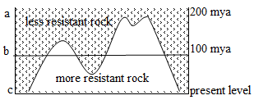 |  | (5 marks)
 |  |  |  |  | Explanation:  - More resistant rock is overlain by a less resistant rock 200 million years ago (mya) (1 mark). After 100 million years the less resistant rock is eroded away (1 mark) due to denudation reducing the less resistant rock to as lower level as b (1 mark).. Continued denudation has exposed the more resistant rock, making them stand as mountains as in c (1 mark). |  | (4 marks)
 |  |  |  |  | Cactus |  | (1 marks)
 |  |  |  |  | - Tropical Desert |  | (1 marks)
 |  |  |  |  | - They have few or no leaves to reduce the less of water.  - They have long roots to reach into deeper layers for moisture.  - The seeds remain dormant in the soil waiting for rain.  - Some vegetations have succulent stems to store water during long droughts.  - Trees have hard stems with thorns to reduce transpiration. |  | (4 marks)
 |  |  |  |  | - Large bodies of water that circulate in the regular patterns around the ocean, or An Ocean current is continuous flow of ocean water in a directed and regular pattern |  | (1 marks)
 |  |  |  |  | Explain how each of the following factors affects the direction of ocean currents:
 |  |  |  |  | - Shape of continents- land masses obstruct and divert a current, hence changing its direction, or ocean currents follow the coastal outline and sometimes they are split into two when they meet a land mass. |  | - marks)
 |  |  |  |  | - Prevailing winds on the global cause ocean currents to be following the direction of the trade winds, westerlies and polar easterlies. |  | (2 marks)
 |  |  |  |  | Explain any two positive effects of ocean currents on shipping.  ____________________________________________________________________________________________________________________________________________________________________________________________________________________________________________________________________________ |  | (4 marks)
 |  |  |  |  | Figure 3 shows main wetlands of Malawi. Use it to answer questions that follow.  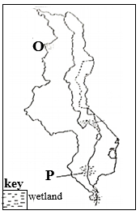 |  | (3 marks)
 |  |  |  |  | Name the wetlands marked O and P  O: Vwaza Marsh |  | (1 mark)
 |  |  |  |  | P: Elephant Marsh |  | (1 mark)
 |  |  |  |  | Explain how wetlands help to:  - Reduce the emission of carbon dioxide- wetland plants absorb large amounts of carbon dioxide from the atmosphere during photosynthesis. Wetlands lock up carbon in the form of peat, thus preventing it from entering the atmosphere as carbon dioxide. |  | (2 marks)
 |  |  |  |  | - Maintain clean water in lakes and rivers - wetlands trap sediments and preventing them from entering water bodies. Wetlands filter out pollutants, such as heavy metals and pesticides, improving water quality. |  | (2 marks)
 |  |  |  |  | Any two strategies for maintaining wetlands in Malawi.  - Awareness campaigns or civic education on the importance of wetlands.  - Proper waste disposal: people should be actively engaged in conserving wetlands through avoiding pollution of water resources.  - Communities and individuals can be encouraged to promote and enhance good agricultural practices.  - Afforestation and reafforestation should be an ongoing practice by communities and individuals to prevent siltation in wetlands. |  | (4 marks)
 |  |  |  |  | Two causes of water pollution.  - Disposal of waste in water by industries.  - Oil leakages into water masses pollute the water.  - Fishing using chemicals and poisonous herbs pollutes the water.  - Improper disposal of human and animal waste pollutes water |  | (2 marks)
 |  |  |  |  | Any one harmful effect of air pollution  - Lead to respiratory diseases when exposed to air pollution.  - It causes acid rain which damage plants, soil and buildings.  - Depletion of the protective ozone layer which causes direct Vitra violet lays from the sun reaches the earth’s surface thus causing skin cancer.  - Global climate change is a result of rising global temperatures due to gases suspended in the air. |  | (1 mark)
 |  |  |  |  | How population growth influences desertification.  - An increase in population growth means that there is an increase in demand for food and wood for cooking and heating. This will lead to deforestation to create more land for farming and settlement. The land will be left bare consequently soil erosion occurs which will result in desertification. |  | (2 marks)
SECTION B (25 Marks)

Answer one question only from this section in the spaces provided

 |  |  |  | Instrument used to measure the following aspects of an earthquake.  - Magnitude – Richter Scale |  | (1 marks)
 |  |  |  | - Intensity - Seismograph |  | (1 mark)
 |  |  |  | Any two effects of earthquakes on the environment  - Earthquakes cause landslides and the falling rocks block rivers and, in the process, cause floods.  - Earthquakes lead to the spread of diseases like cholera because of poor sanitary conditions since water sources are destroyed.  - They tear apart ground surface and destroy forests, hence damaging the ecosystems in the environment. |  | (4 marks)
Figure 4 is a riverine landform. Use it to answer questions that follow.
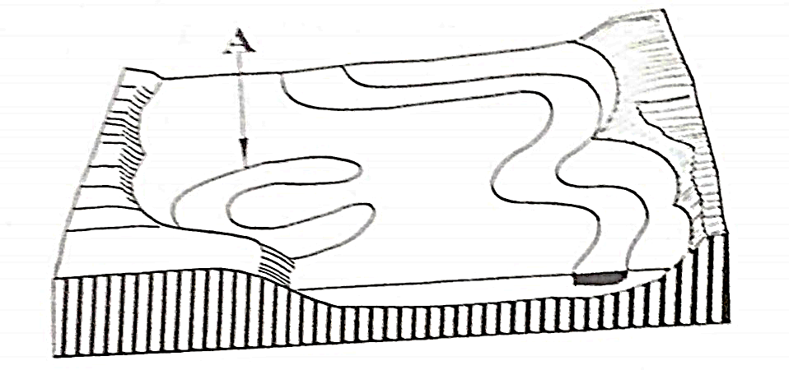
 |  |  |  | - Ox-bow lake |  | (2 marks)
 |  |  |  | How the riverine landform in b (i) above develops  - An ox-bow lake is formed when meander detaches itself from the main river whose pronounced meander had its ends sealed by deposition of silt |  | (4 marks)
 |  |  |  | - The weight exerted by air on the earth’s surface. |  | (1 marks)
 |  |  |  | Sea level pressure (at 0 m) = 1024mb  Pressure at 5000m = 606 mb  Pressure difference = 1024 mb – 606 mb = 418 mb |  | (2 marks)
 |  |  |  | Explain how each of the following factors influence atmospheric pressure:  - Temperature: when temperature rises, it causes air molecules to expand, become less dense and rise. This in turn decreases pressure of air. But when temperatures are low, air molecules contract, become denser and it sinks down causing high atmospheric pressure. |  | - marks)
 |  |  |  | - Latitude: along the equator, the air molecules occupy a larger space because the earth has barged. Therefore, air pressure is low while at the polar regions, air molecules contract to occupy a smaller space. This causes air pressure to be high. |  | - marks)
 |  |  |  | Any one difference between local wind and prevailing winds.  - Local winds are seasonal and blow during a particular period of the year, while prevailing winds blow for a long period of time.  - Local winds blow in a particular area while prevailing winds blow over an extensive region.  - Local winds change direction while prevailing winds do not change their direction. |  | (1 mark)
 |  |  |  | Any two characteristics of local winds.  - They may be regular or periodic.  - They change speed over a short period of time.  - They have a great influence over the area they blow |  | (2 marks)
Any one local wind experienced in southern part of Malawi.
- Chiperoni
- Mwera
 |  |  |  | Figure 5 is a world map showing climatic regions. Use it to answer questions that follow.  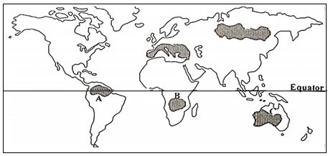 |  | (4 marks)
 |  |  |  | Identify the climates experienced in regions labelled A and C  A: Equatorial Climate |  | (2 marks)
 |  |  |  | B: Tropical continental/Sudan Type/Savanna |  | (2 marks)
 |  |  |  | Explain any two ways through which plants adapt to climatic conditions of the  region labelled C.  - They have long roots to search for underground water.  - Trees are succulent, they have broad trunks to store excess water.  - Grass dries out in the hot and dry season.  - Trees are umbrella shaped to shield their roots from scotching heat.  - Trees shed their leaves to prevent excess loss of water through transpiration |  | (4 marks)
Table 2 shows climate for station X. Use it to answer questions that follow.

MONTH | J | F | M | A | M | J | J | A | S | O | N | D
Temp °C | 24 | 24 | 25 | 25 | 25 | 24 | 23 | 23 | 24 | 25 | 25 | 24
Rainfall (mm) | 215 | 210 | 205 | 220 | 210 | 205 | 200 | 195 | 210 | 220 | 215 | 210

 |  |  |  | - Southern Hemisphere |  | (1 mark)
 |  |  |  | Describe any two unique rainfall attributes associated with the climatic regions represented by the table.  - Heavy rain falls throughout the year.  - Double maximum rainfall is recorded in months following overhead sun.  - Convectional rainfall accompanied by thunder and lightning. |  | (4 marks)
Describe the relationship between temperature and rainfall as shown in the table above.
- High temperature throughout the year influences heavy rains throughout the year/ the higher the temperature the higher the rainfall.
Mention any two countries in Asia which experience the above type of climate.
- Malaysia
- Indonesia
- Singapore
 |  |  |  | Mention the two types of cyclones.  - Tropical cyclone  - Template cyclone |  | (2 marks)
Describe any two weather patterns associated with the arrival of an eye of a cyclone.
- There are calm conditions with little or no wind.
- There is no rain with clear skies
Give two examples of anticyclones.
- South Atlantic High
- Indian Ocean High
Explain any one hazard of anticyclones.
- They bring prolonged heat waves or droughts in summer which are unbearable weather conditions.
- They cause Ice caps and glaciers to melt faster in the mountainous regions which in turn cause floods.

END OF QUESTION PAPER

